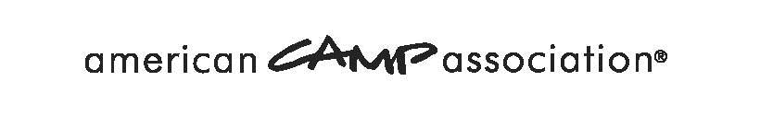
Accessing Course Staff Training in the ACA Learning Center
To access this course for the FIRST time you will need to self-enroll.
Self-Enrollment for those NEW to the Course
Step 1: Go to http://learn.acacamps.org/ and follow the login link in the upper right-hand corner.
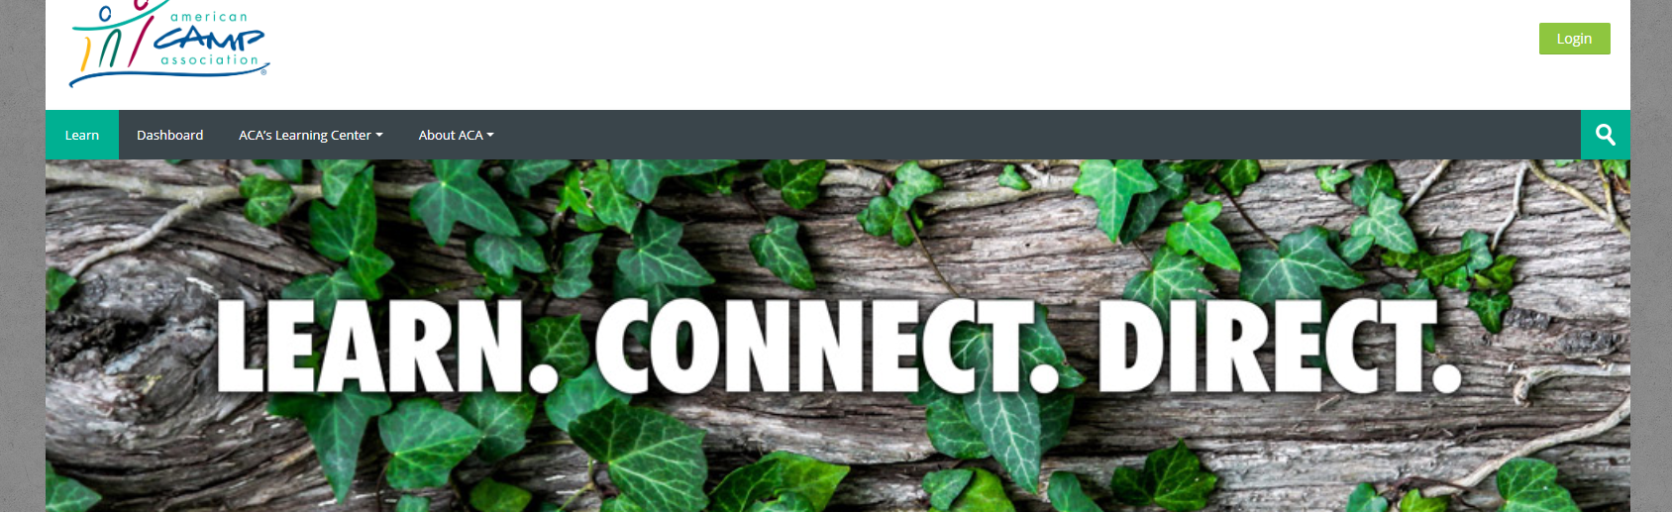
Step 2: Step 1 takes you to this page (https://mx.acacamps.org/SignIn.aspx)
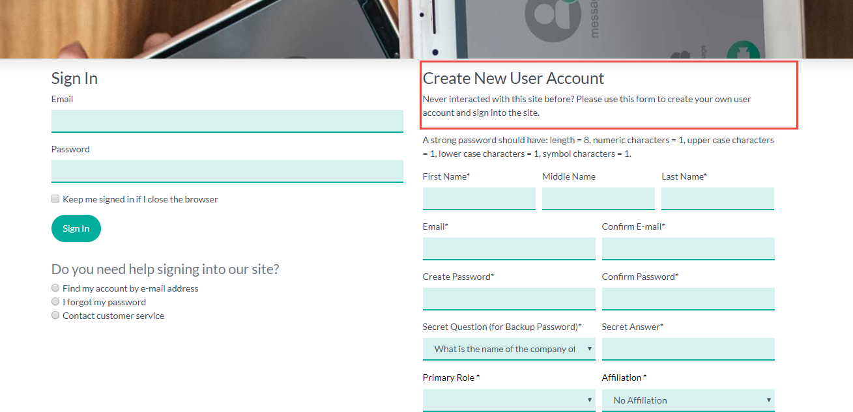
On this page you will create/establish an ACA Account/ID – unique to you. Make note of your username and password as you’ll need them on subsequent trips to the course. Please do not enter an email with capital letters – our system will not log you in.

Step 3: Once Step 2 is complete the system takes you back to the ACA Learning Center http://learn.acacamps.org/ page AND you are Logged-in
Step 4: FIND YOUR COURSE: Type “Redwoods” in the search box at the right side of the website
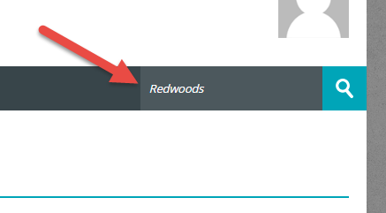
Step 5: Scroll down and choose Camp safety Trainings Package
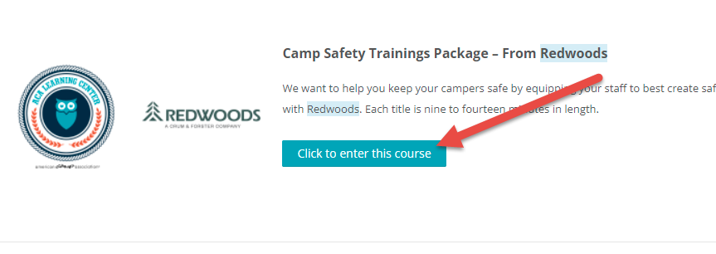
Step 6: Use this enrollment code (case sensitive): KOINONIA2023 to enroll yourself into the course and your camp’s group. Type the enrollment code – do not copy and paste. *If an error message pops up just close it and continue. Scroll down to enter the passcode*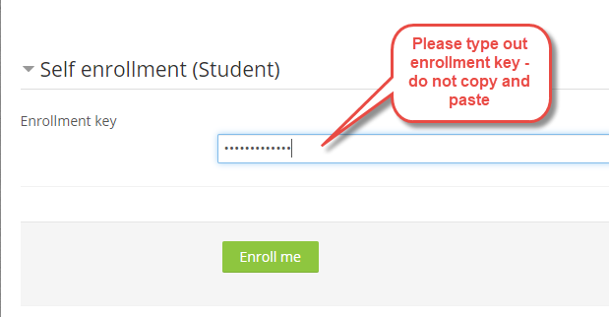

Special Note: You’ll only need to enroll once.
Upon subsequent visits to the Learning Center http://learn.acacamps.org/ – login with your username and password, and access any/all courses you have been enrolled into through the My Courses link in the Navigation block on the learning center home page.

In Summary
Self-Enrollment Steps (No Illustrations):
Step 1: Go to http://learn.acacamps.org/ and follow the log-in link in the upper right-hand corner. It is important that you start here.
Step 2: It will take you to https://mx.acacamps.org/SignIn.aspx. Sign-in with an existing account/ID or create/establish an ACA Account/ID – unique to you. Make note of your username and password as you’ll need them on subsequent trips to the course.
Step 3: Once you have logged in, it bounces you back to the ACA Learning Center (http://learn.acacamps.org/)
Step 4 and 5: Type “Redwoods” in the search box at the right side of the website. Click on your course Camp safety Trainings Package
Step 6: Enroll yourself. Use this enrollment code (case sensitive): KOINONIA2023 to enroll yourself into the course and your camp’s group. *If an error message pops up just close it and continue. Scroll down to enter the passcode *
Upon subsequent visits to the Learning Center http://learn.acacamps.org/ – login with your username and password, and access all of courses you have been enrolled into through the My Courses link in the Navigation block on the learning center home page.

